**INTRODUCTION :**

The Vehicle Management System (VMS) is a comprehensive solution designed to streamline the management of vehicle fleets by automating tasks like maintenance scheduling, fuel tracking, and driver monitoring. It enhances operational efficiency, reduces costs, and ensures vehicle safety through real-time data and centralized management.

**1 . Project Overview:**

The main Objective of the project on Vehicle Management System is to manage the details of Vehicle, Driver, Insurance, Maintenance, Fuel. It manages all the information about Vehicle,Vehicle Type, Fuel, Vehicle.The project is totally built at administrative end and thus only the administrator is guaranteed the access. The purpose of the project is to build an application program to reduce the manual work for managing the Vehicle, Driver Vehicle Type,Insurance. It tracks all the details about the Insurance, Maintenance, fuel .

**2. Purpose :**

The primary purpose of a Vehicle Management System (VMS) is to optimize vehicle usage, reduce costs, improve operational efficiency, and enhance safety by providing tools for tracking, maintenance scheduling, fuel management, and driver behavior monitoring.

# Project Design Phase Problem – Solution Fit Template

|  |  |
| --- | --- |
| Date | 15 February 2025 |
| Team ID | LTVIP2025TMID19432 |
| Project Name | Vehicle Management Using salesforce |
| Maximum Marks | 2 Marks |

**Problem – Solution Fit Template**

The core issue is the inefficiency and time-consuming nature of managing vehicle details such as insurance, maintenance, fuel consumption, and driver information. This results in high operational costs, delays, and an increased likelihood of errors in manual tracking.

**Solution Provided:**

* Real-time tracking of vehicle health and maintenance schedules.
* Automated reminders for insurance renewals and maintenance checkups.
* Fuel consumption tracking to identify cost-saving opportunities.
* Driver behavior monitoring for safety and efficiency.

**Purpose:**

To optimize vehicle usage, reduce management costs, improve operational efficiency, and ensure vehicle safety by providing an all-in-one platform for vehicle tracking, maintenance scheduling, fuel management, and driver monitoring.

○ Reduces administrative workload by automating repetitive tasks.

○ Increases fleet efficiency through real-time data and monitoring.

○ Ensures compliance with regulations by tracking insurance and maintenance.

**Fit with Customer Needs:**

The Vehicle Management System fits the customer’s needs by addressing key pain points such as manual tracking, inefficient vehicle utilization, and high operational costs. The system’s integration of multiple vehicle management components makes it a comprehensive solution that directly aligns with the customer’s demand for streamlined, automated fleet management.

○ Simplification of vehicle tracking and management.

○ Real-time monitoring and maintenance of vehicles.

○ Cost savings through optimized fuel usage and reduced downtime.

**Behavioral Pattern:**

Customers are currently facing frustrations with manual tracking systems, leading to inefficiency and errors. The VMS solves these issues by automating data entry and improving visibility into vehicle and driver performance.

○ Customers prefer a centralized system where all vehicle-related data can be accessed in one place.

○ A majority of fleet managers are looking for tools to predict maintenance needs and optimize fuel consumption.

**Existing Situation:**

Most customers use fragmented tools (spreadsheets, paper-based records, or multiple software) to manage their fleet. These systems are inefficient, prone to errors, and often lack real-time visibility. The VMS improves this by consolidating vehicle, maintenance, fuel, and driver information into one platform, offering real-time insights and notifications.

○ Fleet managers use manual or outdated systems for tracking vehicle data.

○ No centralized platform for vehicle health, fuel usage, or driver behavior.

**Impact of the Solution:**

The solution helps businesses transition to a more efficient, automated fleet management system, leading to reduced operational costs, fewer errors, and increased overall productivity. It also enhances the safety and efficiency of vehicle operations, providing a more streamlined and customer-friendly experience.

○ Increased efficiency in fleet management.

○ Significant reduction in operational costs due to optimized fuel usage and maintenance scheduling.

○ Improved vehicle lifespan and safety standards through predictive maintenance.

**Template:**

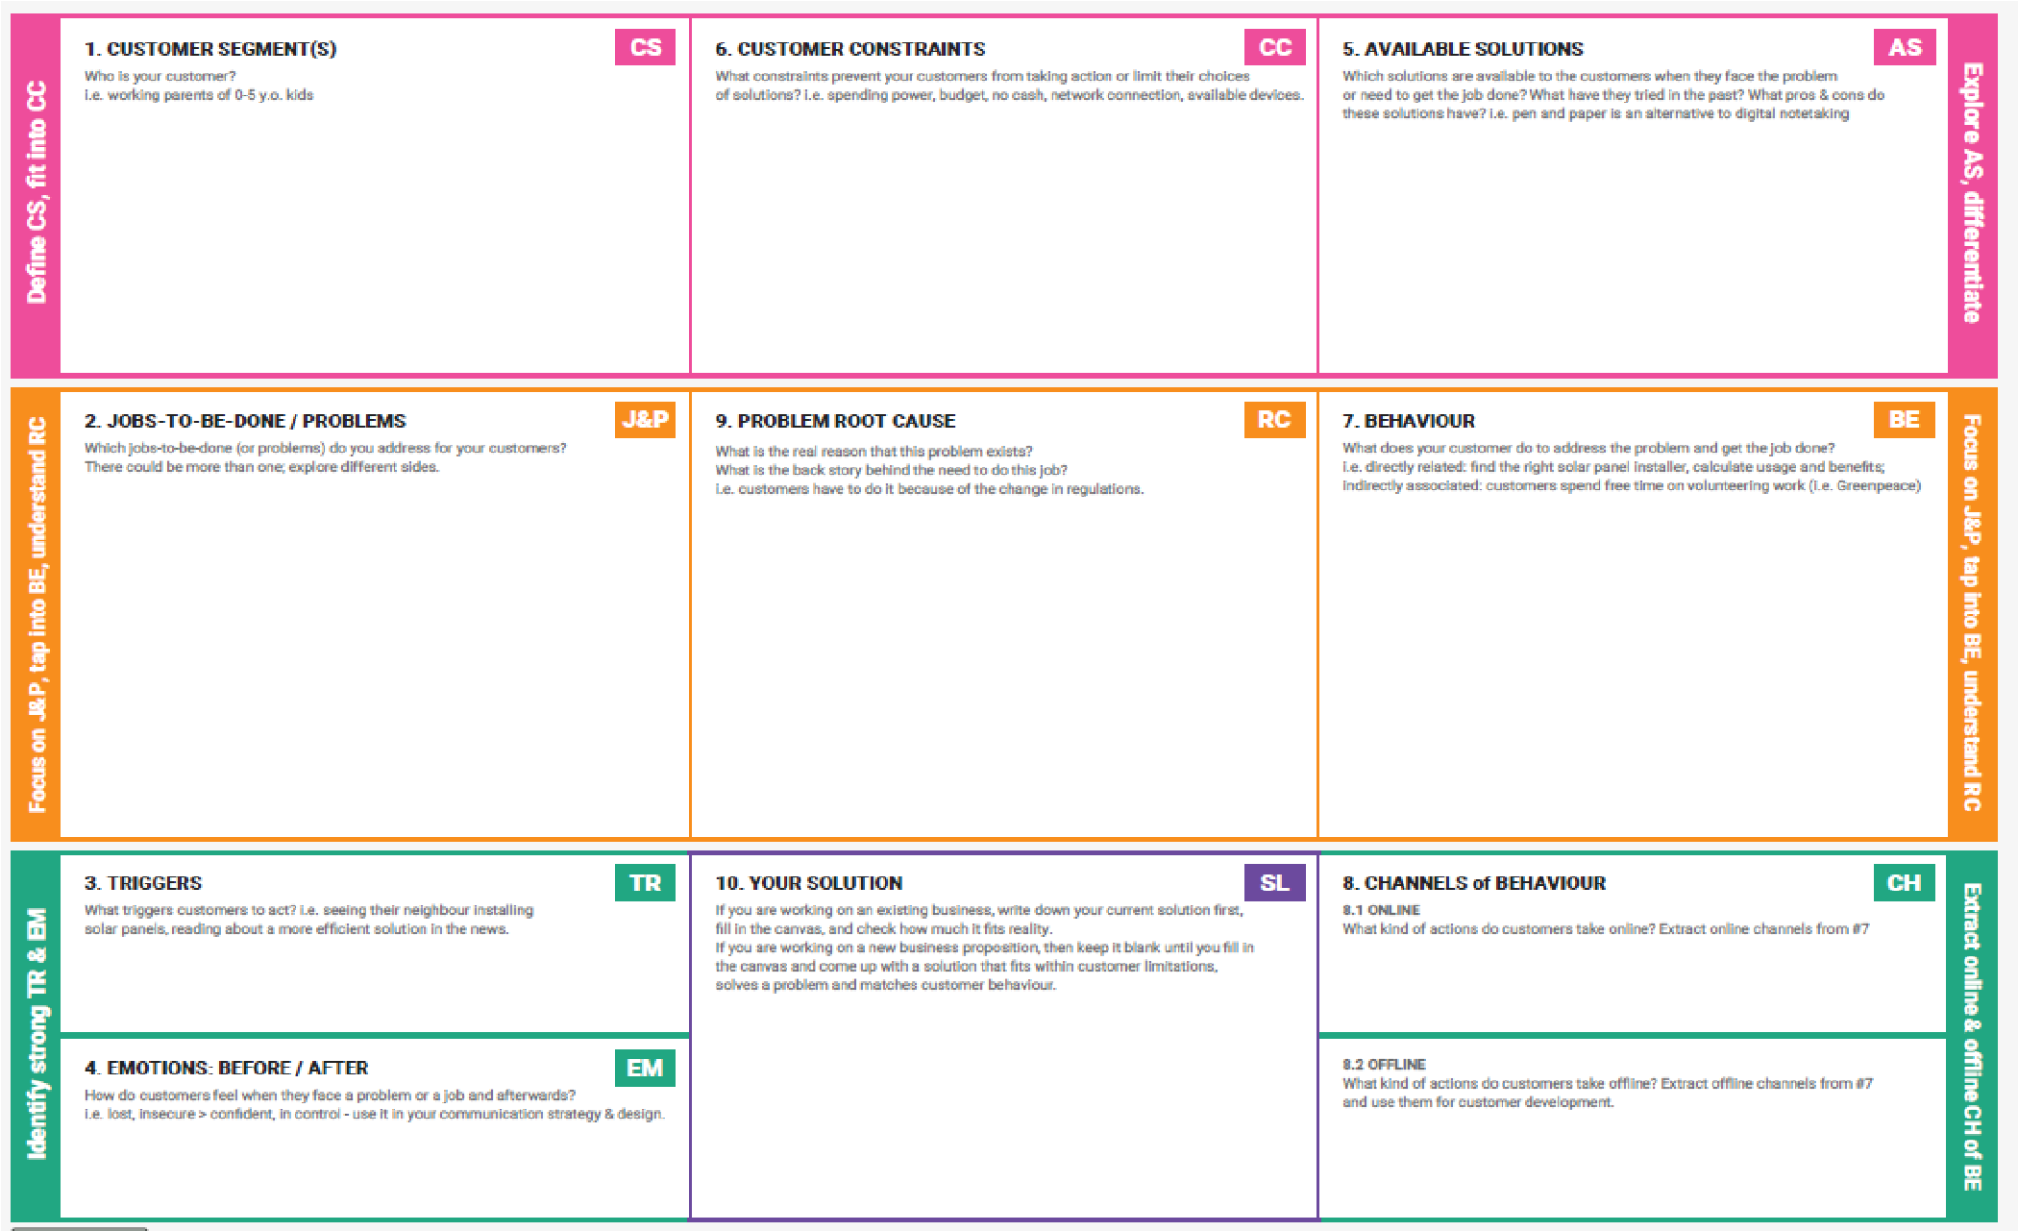

# Project Design Phase Proposed Solution Template

|  |  |
| --- | --- |
| Date | 15 February 2025 |
| Team ID | LTVIP2025TMID19432 |
| Project Name | Vehicle Management Using Salesforce |
| Maximum Marks | 2 Marks |

**Proposed Solution Template:**

Project team shall fill the following information in the proposed solution template.

|  |  |  |
| --- | --- | --- |
| **S.No.** | **Parameter** | **Description** |
| 1. | Problem Statement (Problem to be solved) | Inefficient tracking, high maintenance costs, and poor route optimization are common issues in fleet management, leading to operational inefficiencies. |
| 2. | Idea / Solution description | A cloud-based Vehicle Management System that tracks vehicle health, schedules maintenance, and optimizes routes to improve fleet efficiency and reduce costs. |
| 3 . | Novelty / Uniqueness | Integrates real-time data, AI-powered route optimization, and predictive maintenance to enhance fleet performance, unlike traditional manual tracking methods. |
| 4 . | Social Impact / Customer Satisfaction | Increases operational efficiency, reduces carbon footprint, and ensures timely deliveries, leading to improved customer satisfaction and service reliability. |
| 5 . | Business Model (Revenue Model) | A subscription-based SaaS model offering different service tiers, with additional fees for premium features like advanced analytics and custom reports. |
| 6 . | Scalability of the Solution | The cloud-based architecture allows for easy scalability, supporting fleets of all sizes and expanding to various industries without significant infrastructure changes. |

# Project Design Phase Solution Architecture

|  |  |
| --- | --- |
| Date | 15 February 2025 |
| Team ID | LTVIP2025TMID19432 |
| Project Name | Vehicle Management Using Salesforce |
| Maximum Marks | 4 Marks |

**Solution Architecture:**

"The Vehicle Management System (VMS) is designed to optimize fleet manageme nt by automating tracking, maintenance, fuel management, and driver monitoring."

**Key Features:**

* **Real-Time Tracking:**  Tracks vehicle location and health.
* **Maintenance Scheduling:**  Automatically schedules and reminds for vehicle maintenance.
* **Fuel Management:**  Monitors and optimizes fuel usage.
* **Driver Behavior Monitoring:**  Analyzes driving patterns to improve safety.

**Development Phases:**

* **Phase 1:**  Requirement gathering and planning.
* **Phase 2:**  System design and architecture.
* **Phase 3:**  Development and integration.
* **Phase 4:**  Testing and QA.
* **Phase 5:**  Deployment and maintenance.

**Solution Requirements:**

* **Hardware:**  GPS trackers, IoT sensors, mobile devices.
* **Software:**  Cloud-based platform, mobile/web apps, APIs for integration. ●  **Security:**  Data encryption, secure login, and access controls.

**Specifications and Delivery:**

"The system will be cloud-based, ensuring easy scalability as the fleet grows and providing high availability for real-time tracking."

**Example - Solution Architecture Diagram :**

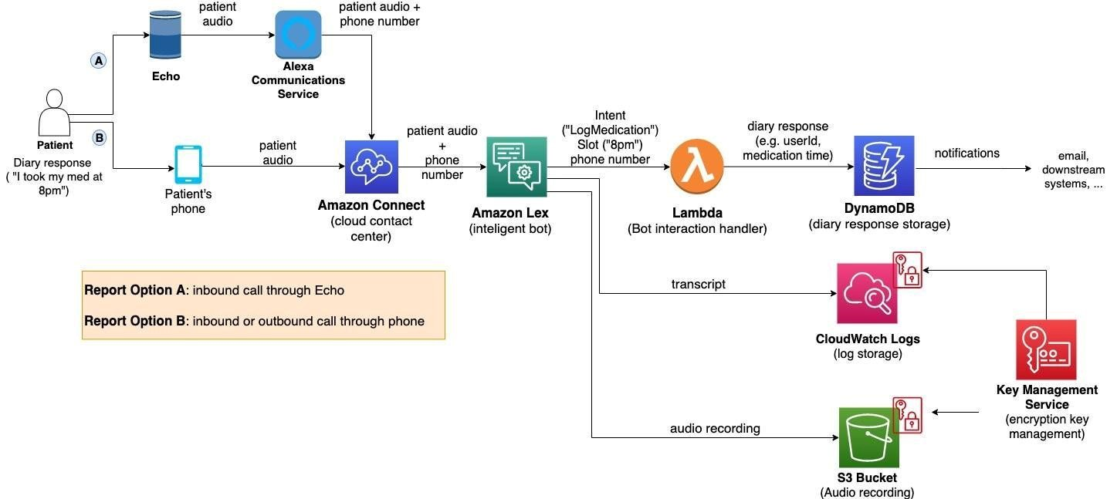

*Figure 1: Architecture and data flow of the voice patient diary sample application*

In summary, your report should clearly present the features, phases, requirements, and technical specifications of the solution, alongside a visual architecture diagram to help stakeholders understand how the system works. Keep the descriptions simple and to the point.

**Conclusion:**

The Vehicle Management System integrates modern technologies to streamline fleet management, providing real-time insights and improving efficiency while minimizing costs."

THANKYOU TEAM SMARTBRIDGE

HEMALATHA(Teamleader)